**SMALLEST NUMBER IN AN ARRAY:**

**EXP NO:11**

**AIM:**To find the smallest number from an array using an 8085 processor.

**APPARATUS:** GNUSim8085

**ALGORITHM:**

1) Load the address of the first element of the array in the HL pair.  
2) Move the count to the B register.  
3) Increment the pointer.  
4) Get the first data in the A register.  
5) Decrement the count.  
6) Increment the pointer.  
7) Compare the content of memory addressed by the HL pair with that of the A register.  
8) If carry=1, go to step 10 or if carry=0 go to step 9  
9) Move the content of memory addressed by HL to A register.  
10) Decrement the count.

**PROGRAM:**

LXI H,2050  
MOV C, M  
DCR C  
INX H  
MOV A, M  
LOOP1: INX H  
CMP M  
JC LOOP  
MOV A, M  
LOOP: DCR C  
JNZ LOOP1  
STA 2058  
HLT

**INPUT:**

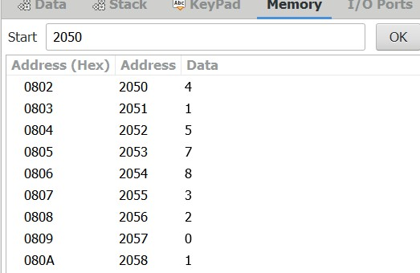

**OUTPUT:**

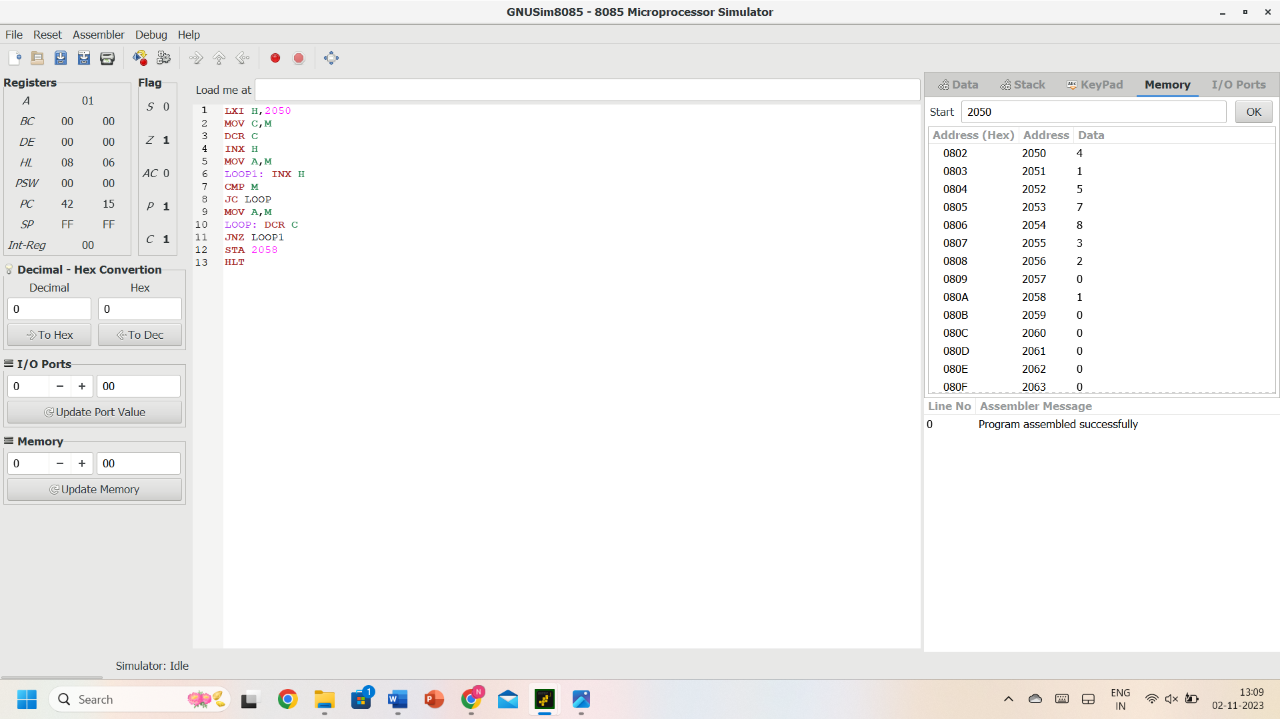

**RESULT:** Thus, the program was executed successfully using 8085 processor simulators.